Asimov, In Joy Still Felt, Doubleday 1980 First Edition, First Print (gutter code V11 March 1980). Fine clipped dust jacket. Fine hard cover with all 626 pages tightly bound and no marks of any kind. Cover design Robert Aulicino 8vo -Not book club or ex-libris-. ISBN 0385155441
The Autobiography of Isaac Asimov 1954-1978. The prolific and famous science and science-fiction writer continues the tale of his life, proceeding from the years immediately following his early successes and continuing through the writing of his 200th book.

ID 000341 Price $170 Box 7
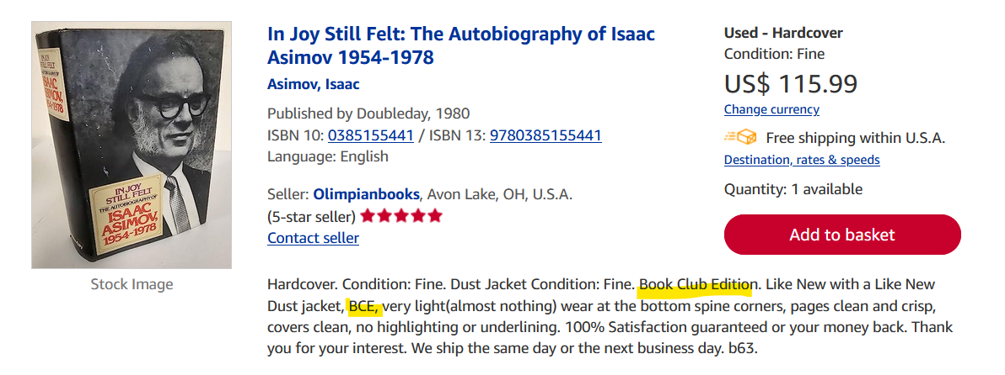AbeBooks New $1,147 Used $23 to $115
Amazon $65 ebay $10

